Tutorial design ideas

Everytime a machine is introduced, one level/factory should be decicated to just using that machine as part of the solution, e.g. to show how conveyors work, the player just needs to transport an ingredient from the output, to a grinder/oven/brewer/etc. (pre-placed as part of the level) to the output. This can also show how another machine works, but that isn’t the focus.

Pre-placement of machines (oven/brewer/grinder/etc.) can work as a tutorial and as an added difficulty element of the level, as players have to use that machine but also be efficient to get a better score.

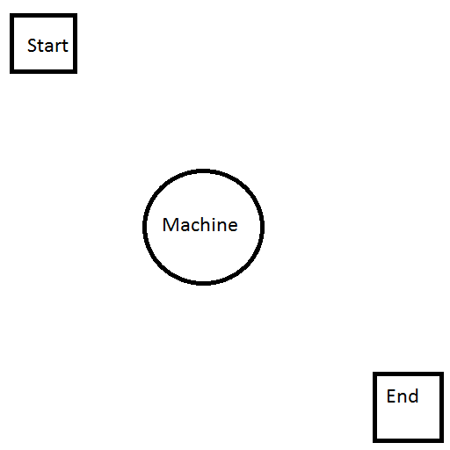

Player has this as the starting point of the level, they just need to place conveyors between the start, machine and end, thus completing the level.

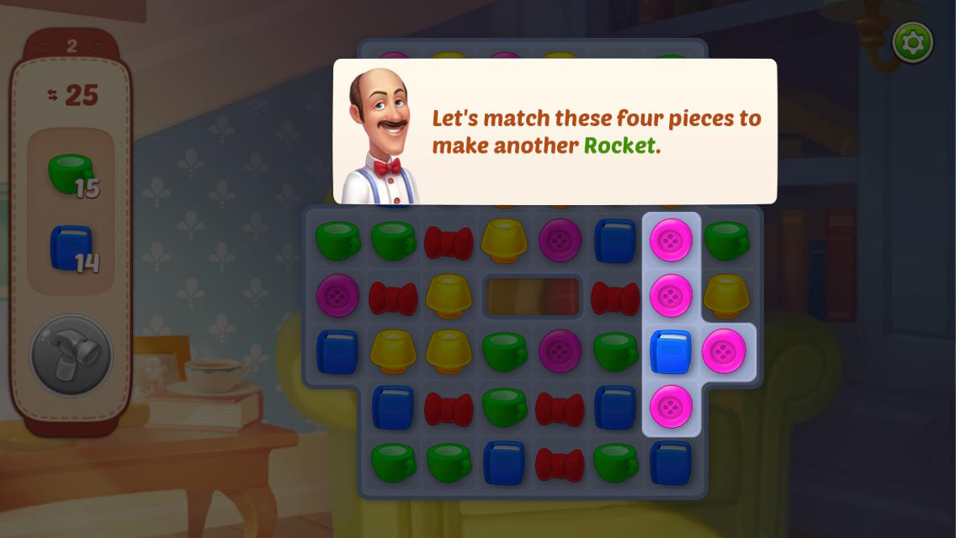One full cookbook tutorial would likely be required, as this tells the player all information for the potion they need to make. This could be done by only allowing the player to click on ther cookbook and nothing else, possibly with a text box pop explaining whats happening. Sort of like this:

Image Source:

<https://www.gamezebo.com/wp-content/uploads/2017/09/Homescapes_Rocket.jpg>

Player can only do the move the game says to do, thus teaching them that matching 4 creates a power up. We can use this as a way to highlight the cookbook, so the player can only click on it, to see the information.

Should be at least three levels between each new machine so the player can effectively go through the learn, practice, master loop. Ideally, 5 levels between each new machine, but three would be the minimum.

Tutorial shouldn’t be too text heavy, as players want to do actions, not read lots of text. Therefore, they should be shown how to do things, e.g. tap here to place a conveyor, rather than explaining how to place conveyors.

“George Fan, the creator of the fantastic Plants vs Zombies, [goes by the rule that "there should be no more than eight words on the screen at any time"](http://www.gamasutra.com/view/news/165359/GDC_2012_10_tutorial_tips_from_Plants_vs_Zombies_creator_George_Fan.php). Players generally have short attention spans, and are not looking to digest large quantities of information.” – direct quote from this article online: <https://gamedevelopment.tutsplus.com/tutorials/4-ways-to-teach-your-players-how-to-play-your-game--cms-22719>

This ties in with not overwhelming the player, we have a few different machines to tell the player about but the way they are told should be spread throughout the game, not by dumping all of the information on the player at once. Super Meat Boy is a good example of this:

“[Super Meat Boy](http://supermeatboy.com/) spreads its "tutorial" over the first half dozen levels. The first level teaches you the fundamentals: moving left and right and jumping. Level 2 teaches wall jumping. Level 3, sprinting. Once the player has understood these basic concepts, the game starts introducing concepts like spinning blades, disintegrating platforms, and scrolling levels.”

“The first level of Super Meat Boy, in fact, is incredibly difficult to *fail* at. The game uses a technique often referred to as a “[noob cave](http://tvtropes.org/pmwiki/pmwiki.php/Main/NoobCave)”. Essentially, the player starts in a position from which it is impossible to fail—they need to make progress in order to get to a point where they can die. This gives the player a chance to get to grips with the game mechanics, without feeling under threat of enemies attacking or timers running out. ”

We should focus on using interactive tutorials for our game, which is done by “blocking” the player out of the full game and only let them use certain machines placed in certain places, which would created a levekl thats basically impossible to fail, as discussed above.